Zhuyi Dai

Jianchao Jia

CST8215 362

Professor Alemeseged Legesse

Due date: Nov 21,2021

**NBA teams and players data investigation report**

**Abstract**

A magazine wants to write a few articles to introduce the NBA. The magazine will create a database to store the NBA statics. The database will start with recording several popular teams and players. It will also record the cities, coaches and the arena of different teams. If readers want more information about NBA, the magazine will continuously add data to the database.

**Business rules**

**Coach**

1. Each coach must assign an ID. It must be unique.
2. A coach first name, Last name and age are maintained
3. A coach may lead serval NBA teams (laid off during season and hired by another team).

**Team**

1. A team only has one coach.
2. Team Id is unique for NBA and each team accompanies with an ID
3. A team should only belong to one city
4. A team could have multiple players
5. A team could have 1 arena

**City**

1. One city could have multiple teams
2. Each city must assign a code and it is unique for the city
3. The details for city name, country code is maintained

**Player**

1. Each player must have a player_ID and it must be unique
2. Each player must belong to one team.
3. The player’s first name, last name, number, age, position, is maintained.

**Arena**

1. An arena could have serval teams
2. Each arena has a unique name
3. The seating capacity is maintained

.

**ERD diagram**

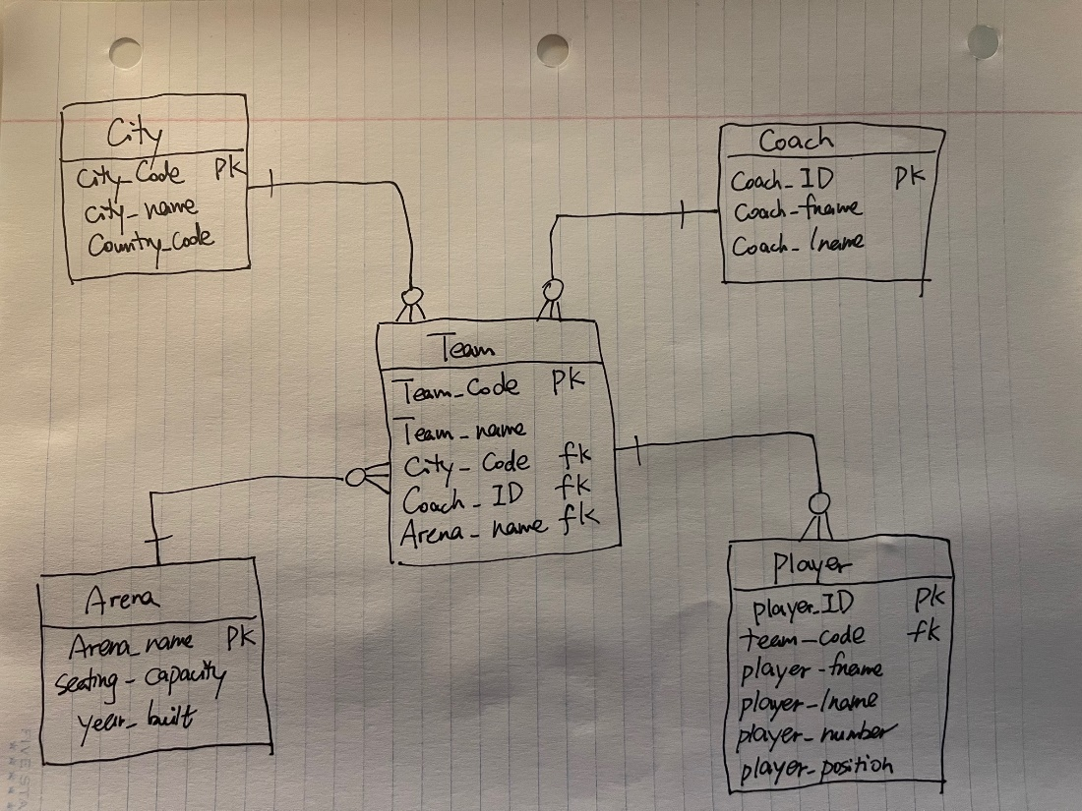

**Metadata**

|  |  |  |  |  |
| --- | --- | --- | --- | --- |
| Name | Type | Len | Description | Source |
| city_code | character varying | 3 | Code of the city | Assigned by System |
| city_name | character varying | 20 | Name of the city | Assigned by System |
| country_code | character | 3 | Code of the country | Assigned by System |
| coach_id | character | 4 | Id of the coach | Assigned by System |
| coach_fname | character varying | 20 | Fname of the coach | Assigned by System |
| coach_lname | character varying | 20 | Lname of the coach | Assigned by System |
| arena_name | character varying | 40 | Name of the arena | Assigned by System |
| seating_capacity | integer |  | Capacity of the seating | Assigned by System |
| year_built | character | 4 | Built of the year | Assigned by System |
| team_code | character | 3 | Code of the team | Assigned by System |
| team_name | character varying | 20 | Name of the team | Assigned by System |
| player_id | character | 4 | Id of the player | Assigned by System |
| player_fname | character varying | 20 | First name of the player | Assigned by System |
| player_lname | character varying | 20 | Last name of the player | Assigned by System |
| player_number | integer |  | Number of the player | Assigned by System |
| player_position | character varying | 5 | Position of the player | Assigned by System |